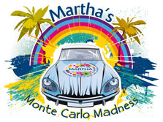
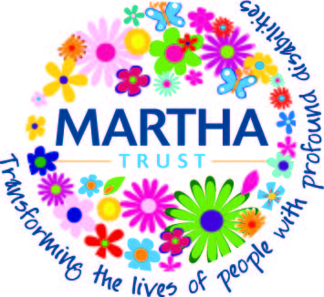

Dear Sir/Madam

We urgently need sponsors for our 2022 car challenge – Monte Carlo Madness.

Our teams will be given just three days to drive to Monte Carlo in cars worth no more than £200. They’ll set out from Dover on Saturday 17th September before reaching Monte Carlo on Monday 19th September.

Last year we raised over £30,000 in sponsorship, a target we hope to beat in 2019.

Martha Trust supports people with profound physical and multiple learning disabilities across Kent and Sussex. Our job is to make sure that everyone who needs our care receives it, and that they feel happy, loved and fulfilled. To do this we need your help.

We’d like you to sponsor our team car, which will be driven by [insert your team members names]. You can choose from our sponsorship package, or simply make a donation of any amount in support of this event:

Sponsorship of £100
The [insert company name] logo printed onto the side of the [insert your team car name] team car.
The [insert company name] logo our website www.marthatrust.org.uk/montecarlomadness
Post-event PR

To find out how you can sponsor our team car, or make a donation call [insert your name] on [insert your phone number] or email [insert your email address]

For a small taste of this epic adventure visit www.marthatrust.org.uk/montecarlomadness

If you’d like to know more about the work of Martha Trust, please see our website www.marthatrust.org.uk

In the meantime, on behalf of everyone who lives and works at Martha, thank you for your support.

Yours faithfully

[your signature]

[insert your name]

