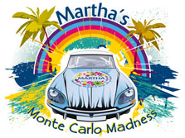
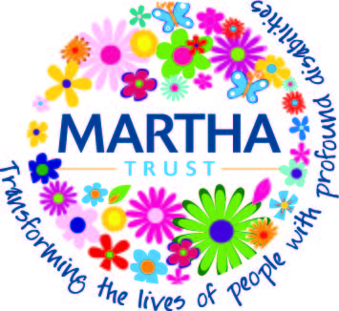

Dear Sir/Madam

I realise that we all receive plenty of charity requests each year but I offer no excuses for sending this one to you.

I have decided to take part in the charity car challenge – Monte Carlo Madness. A team mate and I will be setting off on Saturday 19th September 2020 and have been given just three days to drive from Dover to Monte Carlo.

Where’s the challenge in that you may ask? Well, one of the conditions is that our cars must cost no more than £200.

The charity is Martha Trust, which supports people with profound physical and multiple learning disabilities across Kent and Sussex. You can find out more about their amazing work at www.marthatrust.org.uk

We are committed to raising at least £1,500 for Martha Trust and we will personally be paying for the car, fuel, tax, insurances and obviously any running repairs along the way. Ideally, though, we’d like to raise far more.

Having never run a marathon or cycled the length of the country, we wanted a gentle entry into the world of fundraising, but something requiring a bit more effort than buying a red nose or a charity t-shirt.

I understand completely if you don’t feel able to make a donation but I would like to stress that we’d be grateful for donations of any amount – and I do mean any amount.

We’d also be grateful if you could make your donation through the Gift Aid scheme which means that Martha Trust can get the tax back. We’ve set up a Giving Page to help you at [insert link to your virgin money site]

Cheques can be made payable to Martha Trust and anyone able to donate £100 or more will get a mention on the side of our car.

Thank you in anticipation of your generous donation and we promise to keep you informed of our progress!

Yours sincerely

[your signature]

[insert your name]

