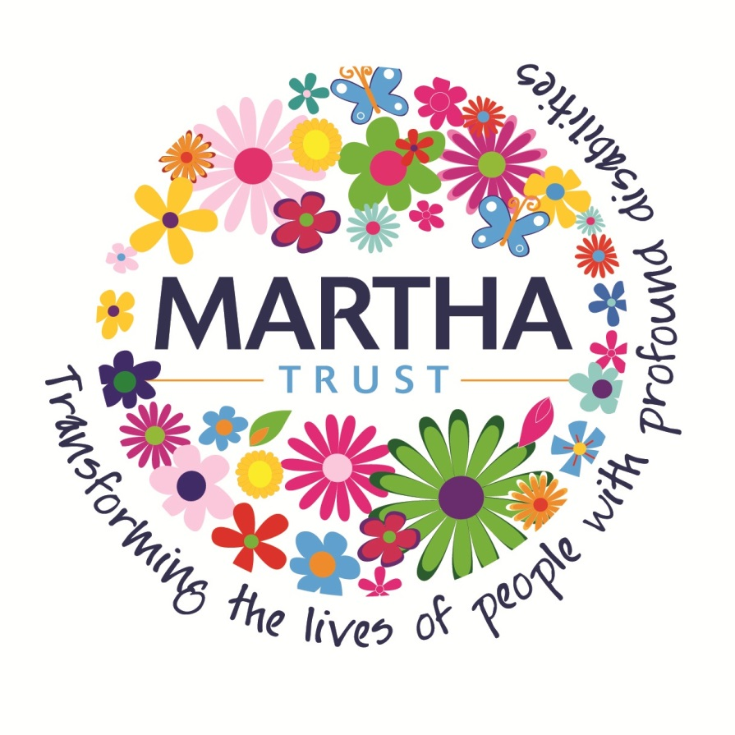
Registered Nurse
Reports To: (Registered) Home Manager Grade: FH JD ID:
Supervises: Support workers and, in the absence of the Registered Home Manager (RHM) and Deputy Home Manager (DHM), support services staff.
Main Purpose
Promote the health and social well being of residents at Martha Trust although the provision of compassionate care and excellent clinical skills.
In conjunction with the RHM and DHM ensure effective management of staff and resources.
Main Duties
- To deliver a high standard of evidence-based nursing care in partnership with the team, the residents and, where appropriate, their family and care managers
- To take appropriate action when working with vulnerable adults following safeguarding vulnerable adult procedures, liaising with appropriate agencies
- Remain up to date with evidence based clinical practice, consistent with relevant NICE guidelines
- Lead shifts, managing, supporting and developing staff as directed by the RHM or DHM
- During a Night shift,
  - remain awake at all times to ensure regular checks on residents are completed and tasks allocated for the night shift, such as wheelchair maintenance etc. are done in a timely and efficient manner.
  - Take responsibility for the whole site and support all care staff on duty by spending time in all areas. On the Deal site this involves spending time in both homes.
- Assess residents’ nursing needs, develop and implement nursing Health Action Plans
- Conduct risk assessments for residents as appropriate and ensure compliance with the recommendations
- Act as Named Nurse for a group of residents as allocated by the RHM or DHM
- To represent the clinical team perspective at multi-disciplinary meetings and clinical reviews of resident care
- Ensure Health Action Plans are implemented effectively and subject to regular review
- Monitor residents’ health, report and respond to changes in condition, involving specialist practitioners as appropriate
- Ensure that all medicines are ordered in a timely fashion and are stored correctly
- Ensure effective internal communication between team members and externally between relevant services and agencies, disseminating information as required
- Maintain accurate, detailed reports and records ensuring it is neat, readily available and in consistent format
- Provide professional advice and guidance to support staff, reporting where necessary to the RHM or DHM any matters concerning breaches of discipline and/or unacceptable performances of duties
- Carry out supervision and appraisal meetings with support staff as allocated by the RHM or DHM
- Provide training to support staff as directed by the RHM and DHM
- Ensure resident’s relatives and friends are welcomed to the home and assist in forming long term, constructive relationships
- To adopt a flexible approach to hours of duty, in order to meet the needs of the service over a 24 hour period. (This may also require on call duties to be paid in addition to salary)
- Maintain current registration with the Nursing and Midwifery Council and work within the guidance of the Code of Conduct
- Ensure participation in clinical supervision and full attendance at mandatory training
- To maintain and contribute to Martha Trust’s policies and procedures
- Carry out any other reasonable duties as directed by the RHM or DHM from time to time

WORKING RELATIONSHIPS AND CONTACTS
Internal:
Residents, Care Staff, Support Services Staff, Managers, SMT, Trustees, other departments within Martha Trust e.g. HR, Marketing
External:
Families, Health Care Professionals, Multi-disciplinary Agencies, Regulatory Bodies
CHRISTIAN ETHOS AND VALUES
The post holder must carry out all duties in a manner which is consistent with Martha Trust policies, procedures and practices, and to maintain at all times the Christian ethos and values of the organisation, ensuring, as far as possible, that all activities within the work setting are consistent with those values.
CONFIDENTIALITY
The post holder must ensure that any information relating to employees (future, current and past) or Service Users is treated in strictest confidence and must be discussed only within the confines of the work setting with the appropriate members of the team or managers.
HEALTH AND SAFETY
The post holder must be familiar with Martha Trust Health & Safety policies and guidelines as well as their legal responsibilities. All work should be undertaken so as to be consistent with these, and so as to ensure own health and safety, and that of others affected by their work.
INFECTION CONTROL
To ensure full compliance with infection prevention and control policies and procedures; through assuming responsibility for your own infection prevention and control practices and reporting potential risks and / or poor practice to the Infection Prevention and Control Link or the Director of Resources & Marketing.

PERSON SPECIFICATION
 | Essential | Desirable
Qualifications | - Registered nurse with current registration | - Further post-qualifications relevant to the role
Knowledge/Experience | - Knowledge of Mental Capacity Act (2005)  - Safeguarding Procedures  - Understanding of Current Care Home Regulations and Standards, including CQC requirements  - Staff supervision and development  - Demonstrate ability to enhance care through evidence-based knowledge | - Able to demonstrate knowledge of the needs of people with PMLD  - Ability to undertake audits as required
Technical | - Computer literate with sound working knowledge of Microsoft and Outlook
Work-based Skills | - Leadership skills, able to manage and co-ordinate a shift effectively  - Ability to supervise junior staff and support workers  - Effective written and verbal skills. Effective team worker. Excellent interpersonal skills  - Analytical skills to assist in diagnosing or highlighting an unmet health need.  Understanding clinical information to formulate recommendations and appropriate intervention/action or referrals to be made.  Undertaking initial resident assessments, risk assessments and support plans.  - Ability to identify own training needs and the needs of others. | - An understanding of infection control and health & safety
Personal Attributes | - Ability to plan and manager time effectively  - Able to work under own initiative  - Ability to deal with unexpected distressing and emotional circumstances  - Enthusiastic and motivated  - Approachable  - Commitment to quality and service  - Non-judgemental attitude
This job description and person specification is not exhaustive and amendments and additions may be required in line with future changes in the post holder duties.
Signed by Employee |  | Date
Signed by Manager |  | Date
Signed by Human Resources |  | Date

